Final Project Report

Project title: Bank Management System

Requirements:

1. Menu driven software system
2. Creating account
3. Updating account
4. Delete account
5. Storing account permanently

Summary

The Bank Management System is a menu driven system that can perform CRUD operation. The system has six different options in menu. The first one is to create account, the account can be saving or checking according to user choice. It asks for the information like account number, beginning balance and annual interest. The account id should be unique every time. Then, the created account is permanently stored in file.

The second one is account enquiry. It asks for the type of account and account id and then search the account id in files. If the id is matched then the account details is displayed.

The third option is for withdraw operation. It asks for the type of account and account id and search the id in files and if the id is matched it loads account operation then asks for withdraw amount then withdraw operation can be performed. At last, the files are updated with new account balance and number of withdraw.

The fourth option is for deposit operation for saving account. It asks for account id and then search id in file, if the id is matched, it if checks account status, if account is active then it asks for deposit amount and deposit operation is performed. At last, the files are updated with new account balance and number of deposit.

The fifth operation is for deleting operation. It asks for the type of account and account id and then search the account id in files. If the id is matched then the account is deleted and files are updated.

The last option is to terminate the program. Until and unless this option is selected the program keeps on executing.

There is an interest function in the system which adds the monthly interest and deducts monthly service charge from balance. This operation is executed once in every first day of the month.

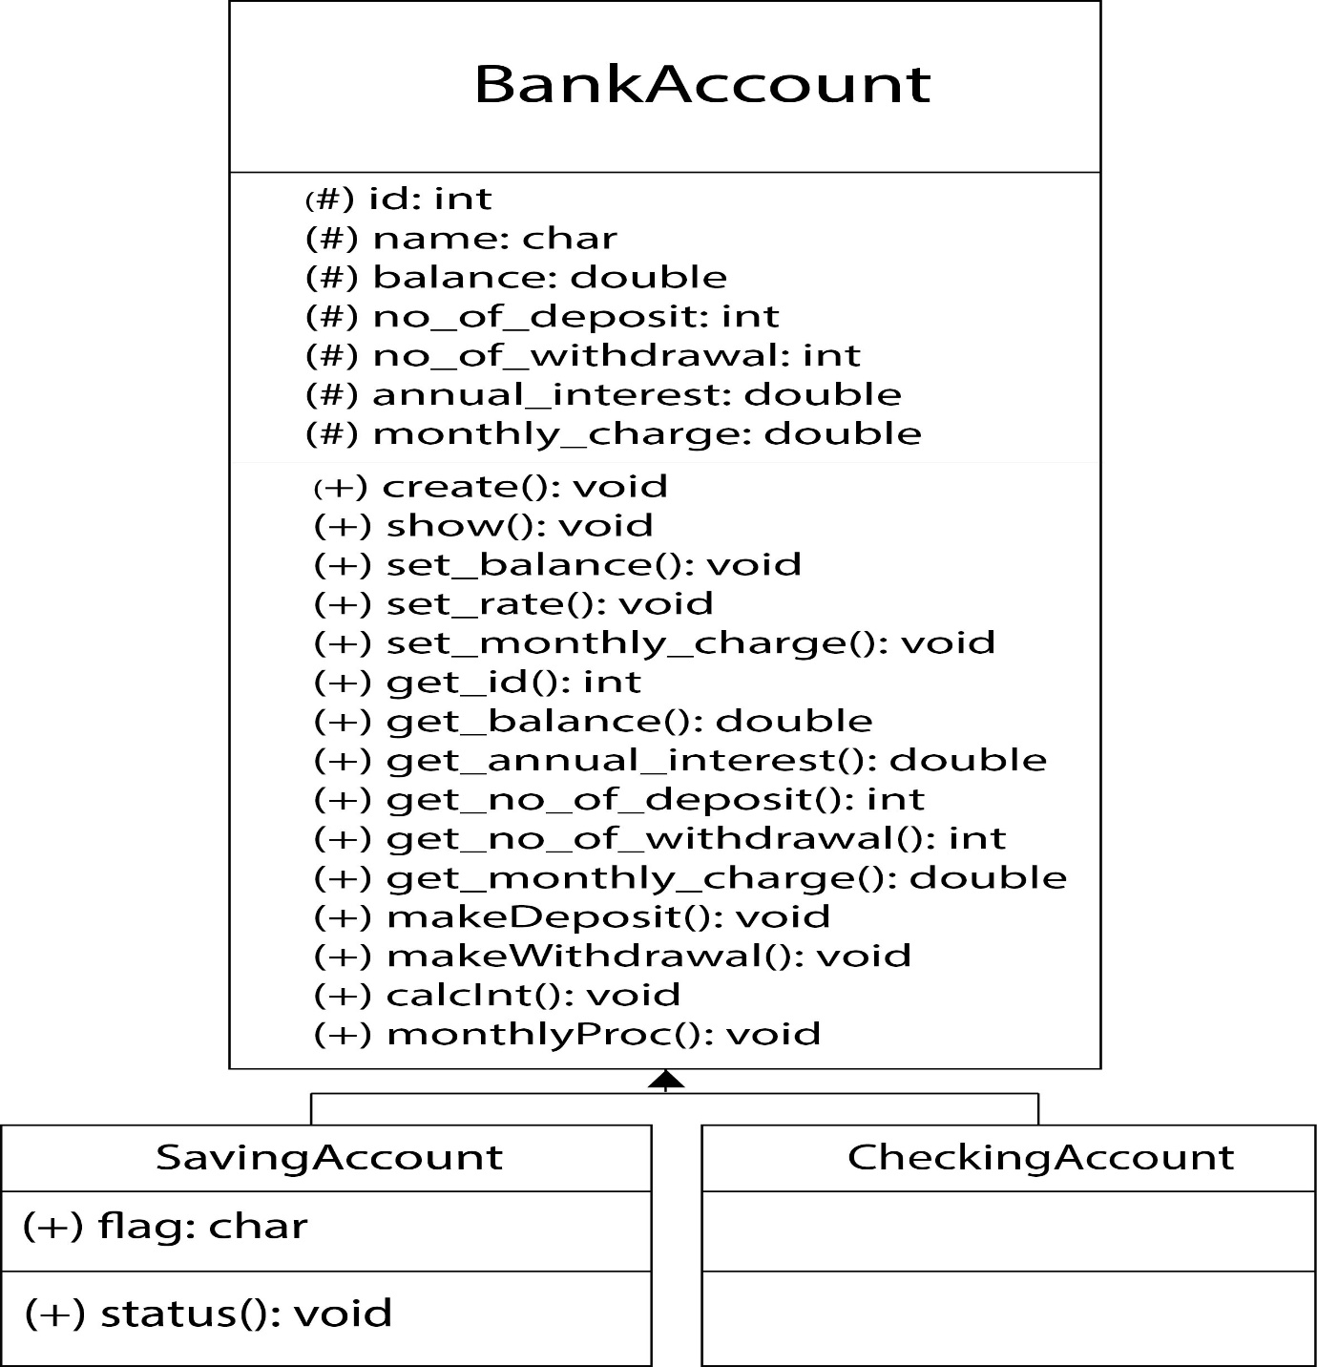**UML**

Submitted by: Shasank Shrestha Submitted to: Sukant Sahu